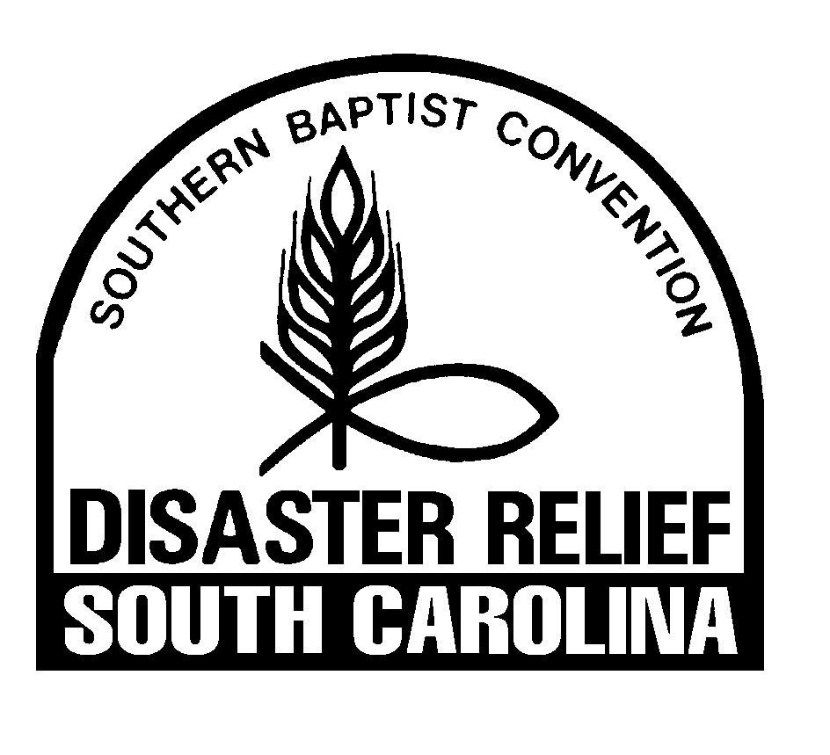

SC Baptist Disaster Relief
Personal Information – Church/Community Volunteers

Name______________________________________________ Date___________________
Address ______________________________________________________________________
City ________________________________ State______________ Zip Code ______________
Cell Phone _____________________________ Other Phone____________________________
Church/Organization ____________________________________________________________
Whom to notify in case of Emergency:
Name________________________________________ Relationship______________________
Cell Phone_______________________________ Other Phone___________________________
Are you allergic to any medication? No ___ Yes ___ If yes, what?________________________
______________________________________________________________________________

Release and Indemnity Agreement

Having fully read the Release and Indemnity Agreement on the other side of this form, this waiver, release and indemnity agreement is fully understood by me and I enter the same willingly for the purposes herein stated.

Witnessed, my hand on this the _________ day of ________________, 20______

________________________________ __________________________________
Signature of Volunteer Signature of Witness

________________________________ ___________________________________
Name of Volunteer (Please Print) Name of Witness (Please Print)

Please read and sign the other side also.

Release and Indemnity Agreement

I do hereby represent and acknowledge that I am entering upon a missionary venture with others, and that as a volunteer I am providing for my own expenses, including insurance, for the purpose of helping in times of disaster for the glory of God; that the work may at times be hazardous and somewhat arduous and will be performed by concerned volunteers and qualified professionals trained in disaster work; that vehicles transporting said volunteers will be operated by volunteers, who may or may not be professional drivers.

I recognize and acknowledge the potential for accidents at the disaster site during activities of the Disaster Relief team, including those involving motor vehicles and am fully aware of possible injuries to members of the Disaster Relief team, including myself.

Therefore, I desire to protect, release, acquit, indemnify, and hold harmless from any and all claims, injuries, damages, losses, expenses or attorney fees incurred by me, my heirs, administrators, executors or assigns.

For and on behalf of myself, my heirs, administrators, executors, assigns, and all other persons, firms or corporations, I do hereby release and discharge from liability all other persons on the Disaster Relief team with me, those who notified, selected or assigned me to the said team, the state Disaster Relief director or department, the Southern Baptist Convention, their employees and representatives, successors or assigns, from any claims, demands, damages, actions, causes of actions which I, the undersigned, have or may hereafter, and on account of, or any way growing out of injuries or damages both to persons or property resulting or that may hereafter result from the voluntary venture.

This waiver, release and indemnity agreement is fully understood by me and I enter the same willingly for the purposes herein above stated.

Witnessed, my hand on this the _________ day of ____________________, 20______

________________________________ ___________________________________
Signature of Volunteer Signature of Witness

________________________________ ___________________________________
Name of Volunteer (Please Print) Name of Witness (Please Print)

